Machine Learning Project



House Prediction using Random Forest Machine Learning Technique

Abstract

Predicting a price variance rather than a specific value is more realistic and attractive in many real-world applications. Price prediction can be thought of as a classification issue in this situation. However, the House Price Index (HPI) is a common tool for estimating the inconsistencies of house prices. Since housing prices are closely correlated with other factors such as location, city, and population, predicting individual housing prices needs information other than HPI. The HPI is a repeat - sale index that tracks average price shifts in repeat transactions or refinancing of the same assets. Therefore, HPI is ineffective at predicting the price of a single house because it is a rough predictor based on all transactions. This study explores the use of Random Forest, linear Regression and Gradient Boosting Regression machine learning technique for house price prediction. UCI Machine learning repository Boston housing dataset with 506 entries and 14 features were used to evaluate the performance of the proposed prediction model. A comparison of all the algorithm is done and we can able to see the significant difference between Linear Regression, Random Forest and Gradient Boosting Regression especially between Random Forest and Gradient Boosting Regression by using Evaluation Metrics like MAE (Mean Absolute Error), MSE (Mean Squared Error), RMSE (Root MSE), R² Score (Coefficient of Determination) and got the difference of 0.3 .

1. Introduction

Housing is one of the integral components that can be used to measure how successful the economy of a nation
is. As the economy increases, people tend to migrate from the urban to rural areas which results to an increase in the population. As the population of urban dwellers increases, the demand for accommodation
increases. As the demand increases, the price of house also increases. In addition to these, the infrastructural
developments in an area can result in a sudden rise in the price of houses in a particular area. For instance, once
the challenges of unmotorable road and unstable electricity a residential area become resolved, house owners
tend to increase the prices of house in that particular area. However,
research has shown that the use of HPI is not enough in this 21st century. Generally, house prices are
influenced by a number of variables. Authors in identified these factors to be physical condition, concept and
location. Physical conditions that can be observed by physical perception include the size of the property, the
number of rooms, the size of the kitchen and garage, the availability of the yard, the area of land and structures,
and the age of the property. Physical characteristics of a house, such as the size of the structure, the year it was
built, the number of bedrooms and bathrooms, and other facts that may define the house's interior features, may
affect the price of a house. Although concepts refer to various marketing tactics employed by developers to
attract potential investors. This includes how close the property is to hospitals, markets, educational institutions,
airports, major roads etc. The location of a property has a significant impact on its price. This is because the
current land price is determined by the area.
Therefore, understanding house price patterns and determining factors is not only a thing of interest to tenants
alone; it is also an issue of interest to home owners, analysts and policy makers in the real estate industry as well
as urban and regional planning authorities. A computer-based prediction system can help them to make informed decision about if a property should be acquired and the best time to acquire the property
Residential real estate is the primary store of equity for the middle class that serves as leverage for new businesses.
However, rising house prices can boost demand by increasing homeowners' income, but they can also promote
debt-financed consumption and weaken financial resilience. Price forecast strategies can be divided into two
categories. The
second approach that involves the use of Random forest algorithm was adopted into his study. Machine learning creates algorithms and builds models
from data, then applies them to new data to make predictions. The key distinction between a model and a
conventional algorithm is that instead of simply executing a sequence of instructions, a model is constructed from
input data. However, this work explores the use of random forest , Linear Regression and gradient boosting Regression learning technique for house price
prediction. UCI Machine learning repository Boston housing dataset was used to evaluate the performance of the
proposed model while Mean Absolute Error (MAE), R² or Coefficient of Determination and the Root Mean
Square Error (RMSE) were used as performance evaluation metrics.

Data Collection and Exploration

In the development of the model, the UCI Machine learning repository Boston housing dataset was used. The
dataset was collected in 1978 and each of the 506 entries represent aggregated data about 14 features for homes
from various suburbs in Boston, Massachusett dataset. Before constructing a regression model, exploratory data
analysis is needed. Therefore, data exploration was carried out to understand the
features present in the dataset and their purpose. The features present in the dataset are: CRIM which is the per
capita crime rate by town , ZN which is the proportion of residential land zoned for lots over 25,000sq.ft, INDUS
which is the proportion of non-retail business acres per town, CHAS which is the charles River dummy variable
(1 if tract bounds river, 0 otherwise), NOX which is nitric oxides concentration(parts per 10 million), RM is the
average number of rooms per dwelling, AGE signifies proportion of owner-occupied units built prior to 1940,
DISis the weighted distance Boston employment centers , RAD is the index of accessibility to fivo radial
highways, TAX is the full-value property-tax rate per $10,000, PTRATIO is the pupil-teacher ratio by town, B
1000(Bk - 0.63) ^2 where Bk is the proportion of blacks by town, LSTAT is the percentage of lower status of
the population and MEDV is the median value of owner-occupied homes in $1000's. Since the model uses a
supervised learning method, the dataset is divided into the training dataset and testing dataset. For the
training dataset, 70% of the dataset was used to train the model while the remaining 30% was used for testing.

Data Pre-Processing

The data acquired for model training and testing should be analyzed appropriately before creating models. Numerical values were normalized, while categorical values
were encoded. After the exploration of the data and selecting the most suitable feature with the use
of the heatmap, the next stage is the pre-processing of the data of the selected features that will be used. Typically,
the datasets acquired for the training and testing task have several features. It is highly probable that the values
of various features are on a different scale which may lower the performance of the model, therefore, scaling was
carried out to ensure that the features are on a relatively similar scale. The Min-Max Scaler function available in
Phyton Skitlearn module was for this task. The Min-Max Scaler assumes that your data is naturally distributed
within each function and scales it so that it is now clustered with in a range from 0 - 1. To measure this we use the following formula;
The formula for Min-Max Scaling (also known as Normalization) is:
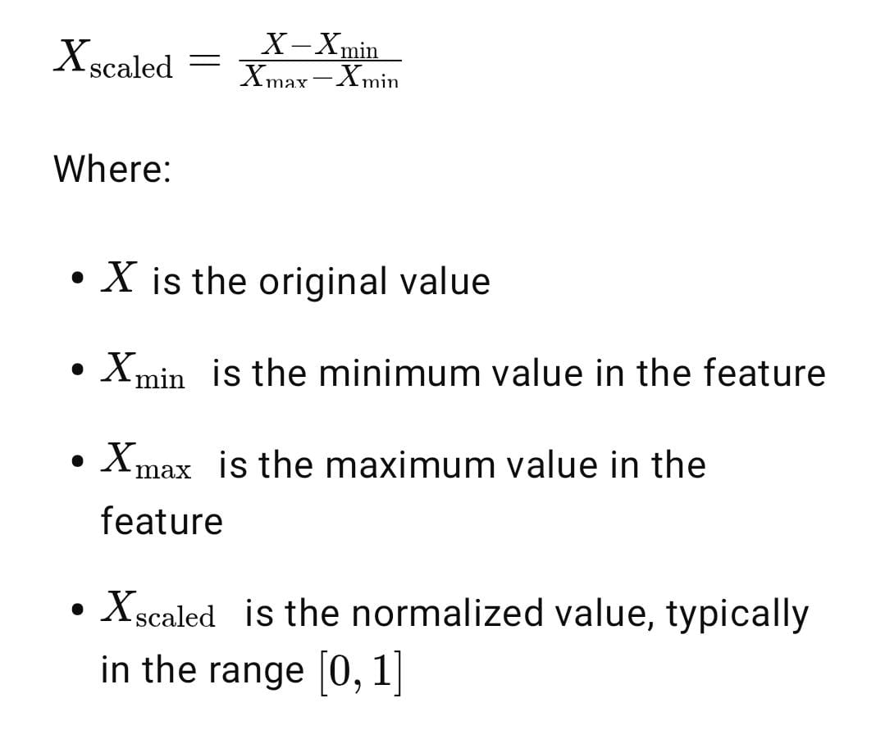

After this we by using Grouped Bar Chart we can visually view the difference between the three algorithms. This is to understand the dataset better since MEDV is the variable that will be forecasted.

Model Development

In the modeling phase of this project, we employed three different machine learning algorithms to compare their performance and select the best predictive model. These were: Linear Regression, Random Forest Regressor, and Gradient Boosting Regressor—all implemented using Python’s Scikit-learn library.

Linear Regression

Linear Regression was the first model used. It's a simple yet effective algorithm that assumes a linear relationship between the input features and the target variable. It works by minimizing the difference between actual and predicted values using a best-fit straight line. Though basic, it's fast, interpretable, and a great baseline for comparison.

Random Forest Regressor
Next, for this used Random Forest, an ensemble method that combines multiple decision trees trained on random data subsets. It makes predictions by averaging outputs from all trees, improving accuracy and reducing overfitting. In this project, built 500 trees by setting n_estimators = 500, and enabled bootstrapping to add randomness and improve generalization.

Gradient Boosting Regressor
Finally, implemented Gradient Boosting, another ensemble model that builds trees sequentially, each one correcting errors made by the previous. It focuses on minimizing a loss function using gradient descent. Though more sensitive to overfitting, it’s very effective for capturing complex patterns in data. fine-tuned parameters like learning_rate, n_estimators, and tree depth for better results.

Data Exploration Process

To understand the dataset better, data exploration was carried out figure show the distribution of the data in each
of the features in the datasets. It shows the total count of the data, the mean, the standard deviation, the minimum
value, 25%,50%,75% and the maximum value. From this, two data columns show interesting summaries. ZN
(proportion of suburban property zoned for lots above 25,000 sq. ft.), with 0 representing the 25th and 50th
percentiles. Second, with 0 for the 25th, 50th, and 75th percentiles, CHAS: Charles River dummy vector (1 if
tract borders river; 0 otherwise). Since both variables are conditional + categorical, these summaries make sense.
The first premise is that these columns will be useless in a regression task like forecasting MEDV (Median value
of owner-occupied homes).

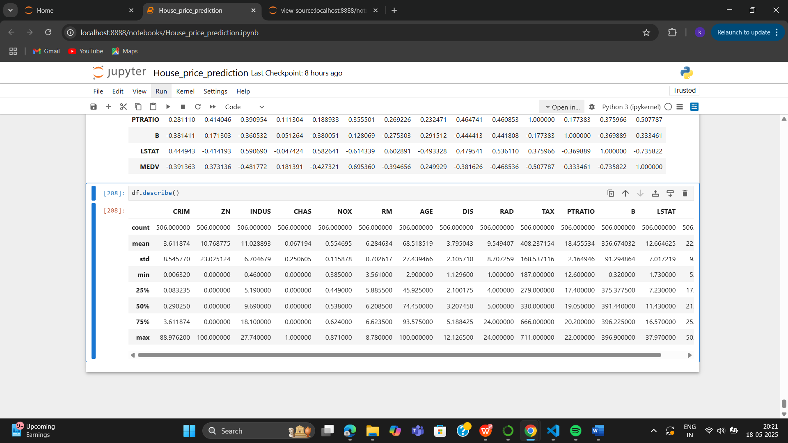

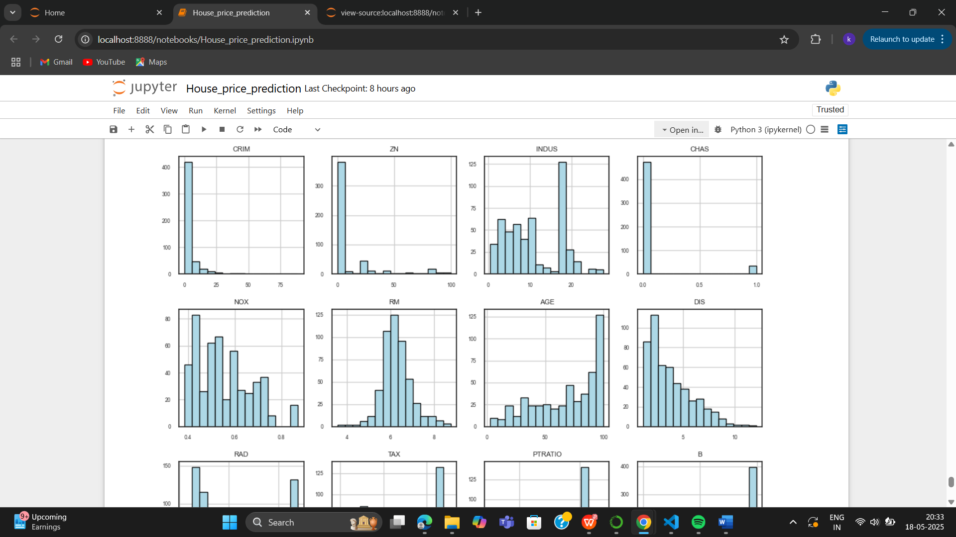

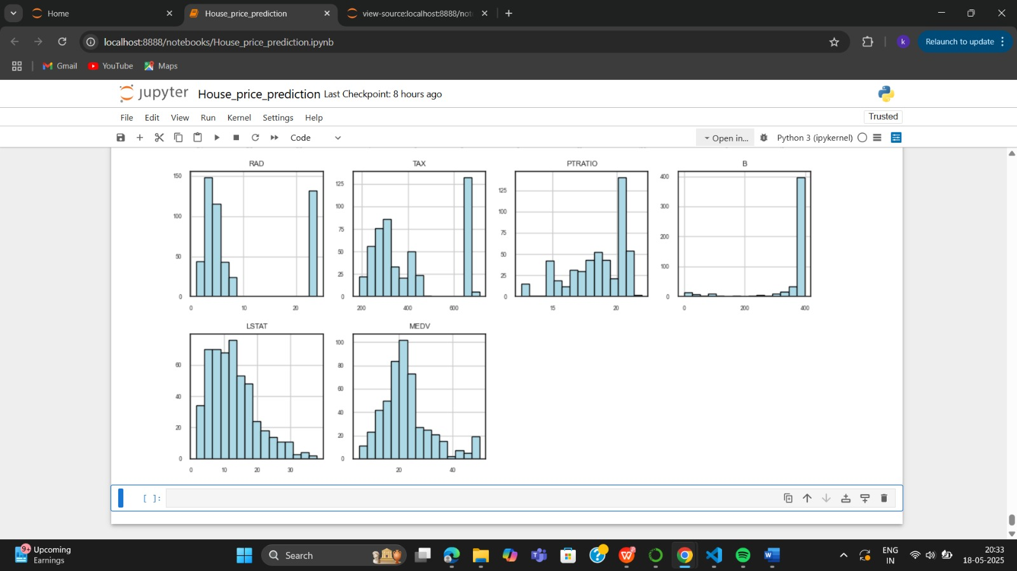

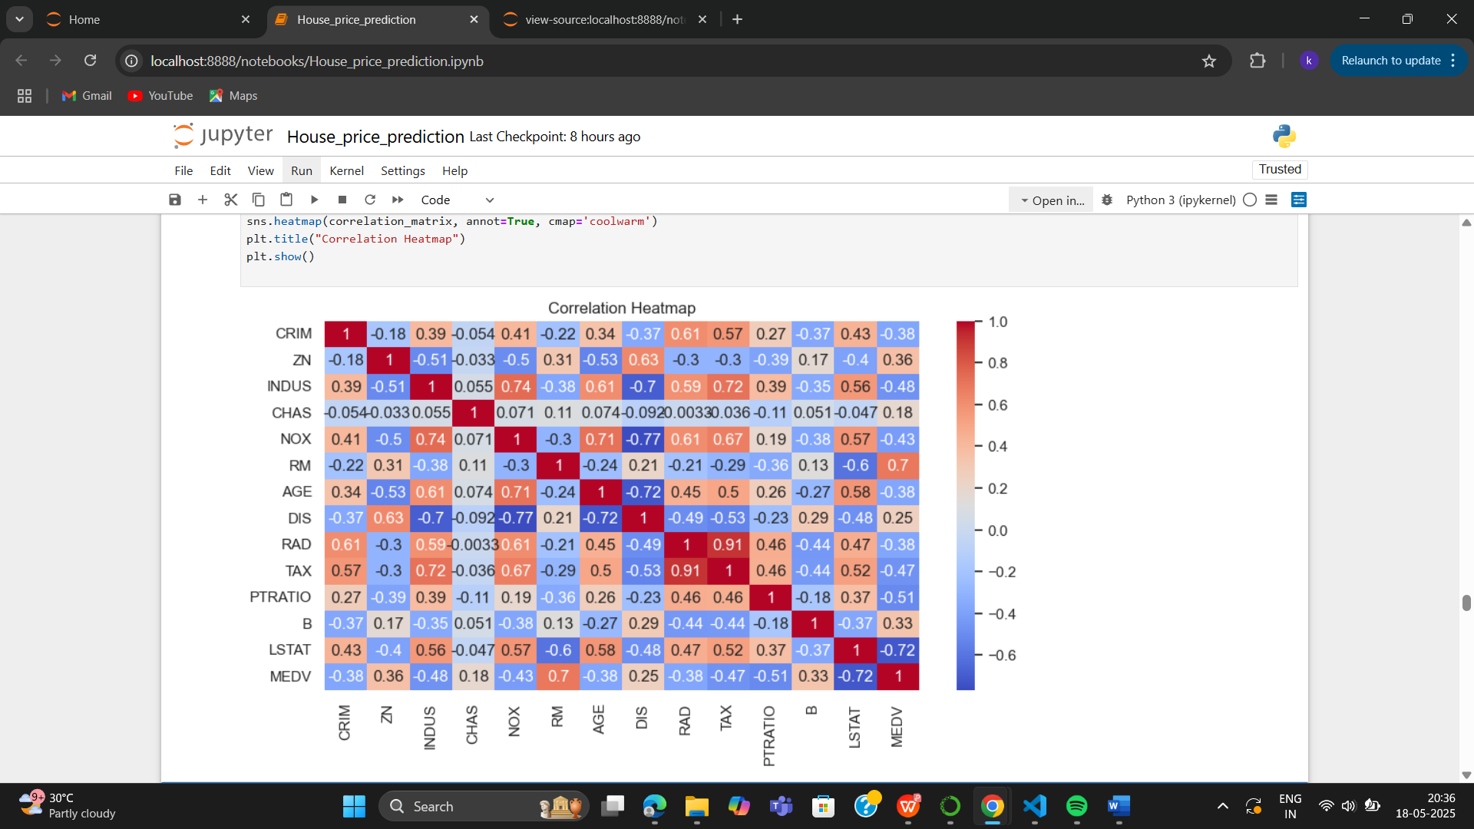

Performance Evaluation of the Proposed Model

After training and testing the model, performance evaluation metrics were used to get the performance of the
model. These are the Mean Absolute Error (MAE), R² or Coefficient of Determination and the Root Mean Square
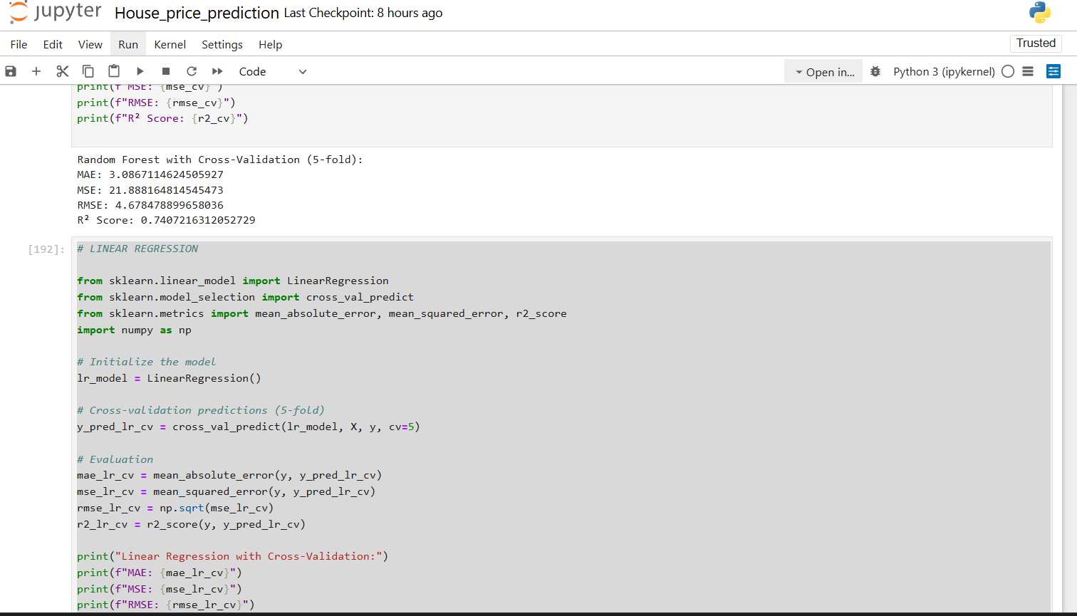
Error (RMSE). The performance of the model based on the metrics is provided in Figure

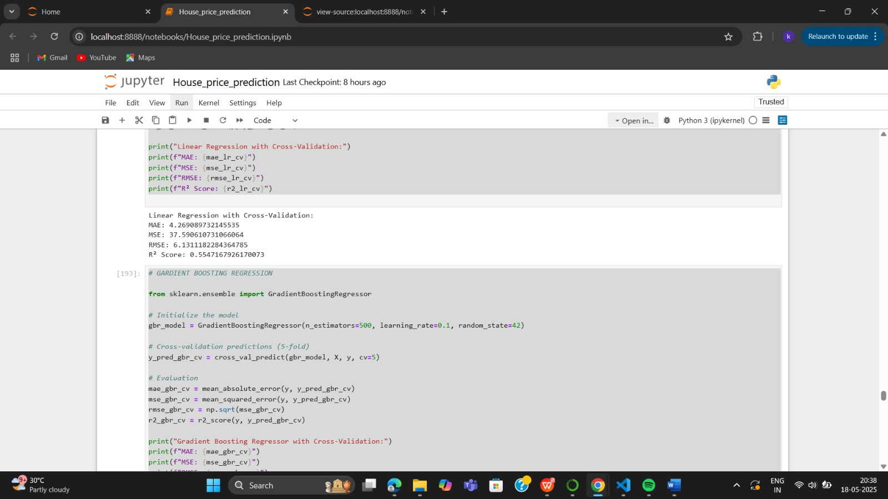
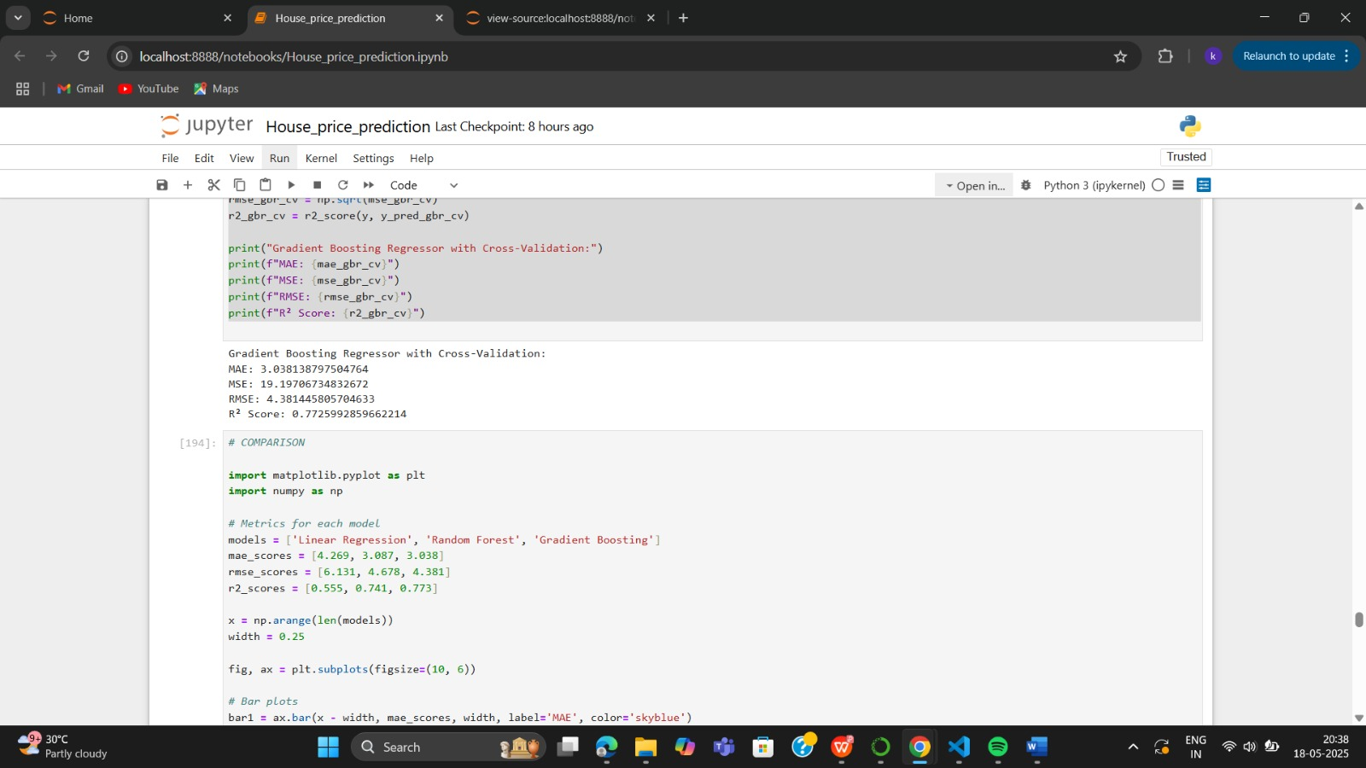

Conclusion

as we can see the evaluation metrics for all the algoriths , here we need to evaluate and notice that whichever algorithm having the lower value of MAE, MSE, RMSE and has a highest value of R² we need to consider that algorithm and that algorithm correctly predicted the house price .
For better understanding , we are visually representing the comparison of the three algorithm and here we can see that when we compare the linear regression , random forest regression and gradient boosting regression we see that the linear regression have the have the highest value of MAE, MSE, RMSE and lowest value of R² .
And in Random forest models and gradient boosting regression both have the lowest value of MAE, MSE, RMSE and the greatest value of R² .

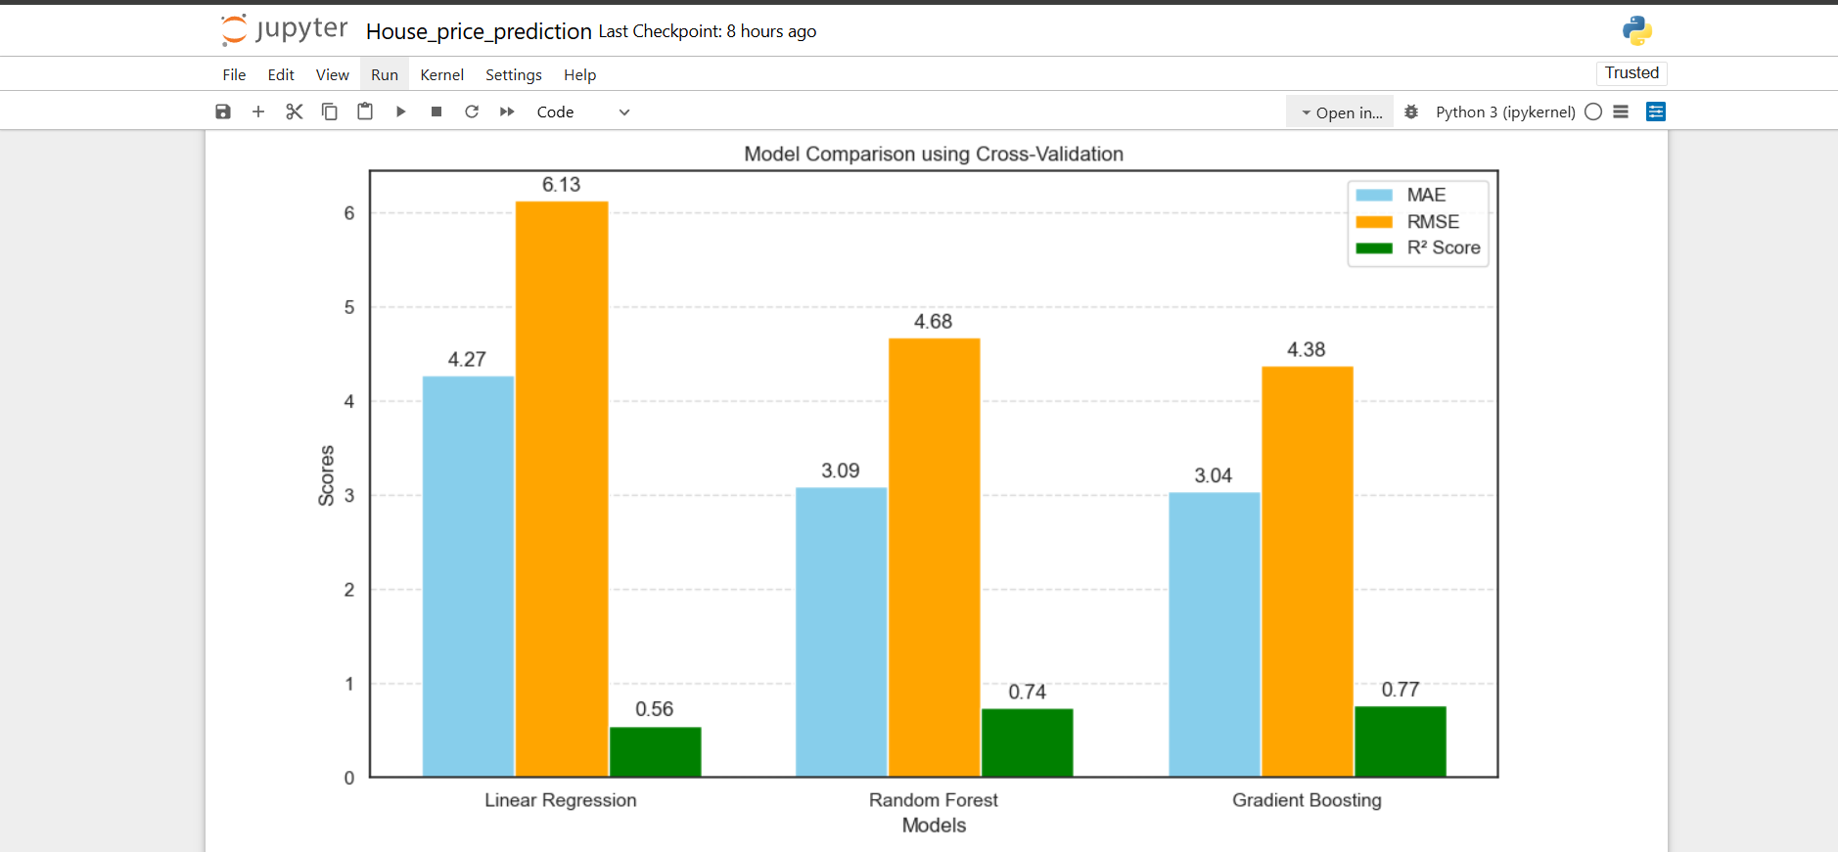
But as we can see by the difference of 0.3 value we are concluding that the best way to predict the house price is Gradient Boosting Regressor

Presented by:
P KRITIKA
P PRAVALIKA

